**ASSIGNMENT – 3**

1. Write a shell script to create a function.

**Code:**

#!/bin/bash

function F1()

{

echo "I love Rain"

}

F1

**Output:**



1. Write a shell script to calculate area of a rectangle using a function.

**Code:**

#!/bin/bash

Rectangle_Area()

{

area=$(($1 * $2))

echo "Area of rectangle is $area"

}

Rectangle_Area 10 20

**Output:**



1. Write a shell script to check whether the username and password is valid.

**Code:**

#!/bin/bash

echo -n "Enter the Username: "

read name

echo -n "Enter the Password: "

read -s password

if [[ $name = "Rupak" && $password = "2002" ]]

then

echo -e "\nLogin Successful"

else

echo -e "\nInvalid Credentials"

fi

**Output:**

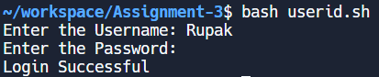

1. Write a shell script to search a city location.

**Code:**

#!/bin/bash

echo -n "Enter the name of the city: "

read city

if [ $city = "Bangalore" ]

then

echo "Located at East"

elif [ $city = "Chennai" ]

then

echo "Located at West"

elif [ $city = "Mumbai" ]

then

echo "Located at North"

elif [ $city = "Pune" ]

then

echo "Located South"

else

echo "Invalid city"

fi

**Output:**



1. Write a shell script to print 1 to n using for & while loop.

**Code:**

#!/bin/bash

for i in {1..10}

do

echo -n "$i "

done

**Output:**



**Code:**

#!/bin/bash

i=0

while [ $i -le 10 ]

do

echo -n "$i "

i=$(( $i + 1 ))

done

**Output:**



1. Write a shell script for number games.

**Code:**

#!/bin/bash

echo -n "Enter your number: "

read n1

if [[ $n1 = 25 || $n1 = 35 ]]

then

echo -e "\nWinner Winner Chicken Dinner!!"

else

echo -e "\nBetter luck next time :("

fi

**Output:**

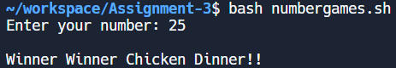

**Code:**

#!/bin/bash

echo -n "Enter your number: "

read n1

if [ $n1 -eq 25 ]

then

echo -e "\nWinner Winner Chicken Dinner!"

elif [ $n1 -eq 35 ]

then

echo -e "\nYou have won the second prize!"

elif [ $n1 -eq 45 ]

then

echo -e "\nYou have won the third prize!"

else

echo -e "\nBetter luck next time :("

fi

**Output:**

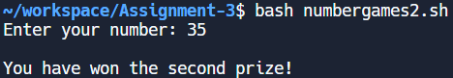

1. Write a shell script to swap two numbers with & without using third variable.

**Code:**

#!/bin/bash

echo -n "Enter the value of a: "

read a

echo -n "Enter the value of b: "

read b

echo "Before swapping, a = $a and b = $b"

a=$(( $a + $b ))

b=$(( $a - $b ))

a=$(( $a - $b ))

echo "After swapping, a = $a and b = $b"

**Output:**

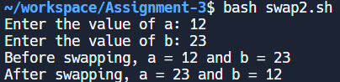

**Code:**

#!/bin/bash

echo -n "Enter the value of a: "

read a

echo -n "Enter the value of b: "

read b

echo "Before swapping, a = $a and b = $b"

c=0

c=$a

a=$b

b=$c

echo "After swapping, a = $a and b = $b"

**Output:**

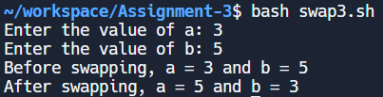

1. Write a shell script to input three numbers, calculate sum and average and check their grades.

**Code:**

#!/bin/bash

echo -n "Enter the three marks: "

read m1 m2 m3

sum=$(( $m1 + $m2 + $m3 ))

avg=$(( $sum / 3 ))

echo "Sum = $sum"

echo "Average = $avg"

if [ $avg -ge 90 ]

then

echo "Grade = O"

elif [ $avg -ge 80 ]

then

echo "Grade = E"

elif [ $avg -ge 70 ]

then

echo "Grade = A"

elif [ $avg -ge 60 ]

then

echo "Grade = B"

elif [ $avg -ge 50 ]

then

echo "Grade = C"

elif [ $avg -ge 40 ]

then

echo "Grade = D"

else

echo "Grade = F"

fi

**Output:**

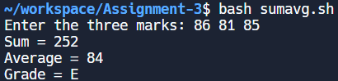

1. Write a shell script to input three numbers and find the greatest among them.

**Code:**

#!/bin/bash

echo -n "Enter the value of a: "

read a

echo -n "Enter the value of b: "

read b

echo -n "Enter the value of c: "

read c

if [ $a -gt $b ] && [ $a -gt $c ]

then

echo "$a is the largest number"

elif [ $b -gt $a ] && [ $b -gt $c ]

then

echo "$b is the largest number"

else

echo "$c is the largest number"

fi

**Output:**

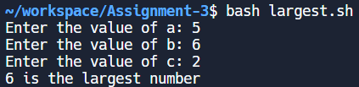

1. Write a shell script to find the sum of digits.

**Code:**

#!/bin/bash

read -p "Enter the number: " num

sum=0

while [ $num -gt 0 ]; do

digit=$((num % 10))

sum=$((sum + digit))

num=$((num / 10))

done

echo "Sum of digits: $sum"

**Output:**